“Time Series Databases New Ways to Store and Access Data” by Ted Dunning and Ellen Friedman

*QUOTES:*

-The basis of a time series is the repeated measurement of parameters over time together with the times at which the measurements were made.

-A TSDB is optimized for best performance for queries based on a range of time.

-Use a non-relational TSDB when you: • Have huge amount of data • Mostly want to query based on time

-Thanks to new technologies to store and access large-scale time series data in a cost-effective way, time series data is becoming ubiquitous.

-Parafrazirano: Koliko različitih vremenskih serija postoji? Kakvi podaci se prikupljaju? Kojom brzinom se prikupljaju podaci? Koliko dugo podaci moraju biti sačuvani? Odgovori na ova pitanja pomažu odrediti najbolju strategiju implementacije.

“Making Sense of NoSQL; A guid for managers and the rest of us” by Ann Kelly

-NoSQL is a set of concepts that allows the rapid and efficient processing of data sets with a focus on performance, reliability, and agility.

Influx Documentation:

The measurement acts as a container for tags, fields, and the time column, and the measurement name is the description of the data that are stored in the associated fields. Measurement names are strings, and, for any SQL users out there, a measurement is conceptually similar to a table.

Fields are a required piece of the InfluxDB data structure - you cannot have data in InfluxDB without fields. It’s also important to note that fields are not indexed. Queries that use field values as filters must scan all values that match the other conditions in the query. As a result, those queries are not performant relative to queries on tags (more on tags below). In general, fields should not contain commonly queried metadata.

Tags are optional. You don’t need to have tags in your data structure, but it’s generally a good idea to make use of them because, unlike fields, tags are indexed. This means that queries on tags are faster and that tags are ideal for storing commonly queried metadata.

In InfluxDB, a series is a collection of points that share a measurement, tag set, and field key.

A point represents a single data record that has four components: a measurement, tag set, field set, and a timestamp. A point is uniquely identified by its series and timestamp.

InfluxDB is a schemaless database which means it’s easy to add new measurements, tags, and fields at any time.

IMPLEMENTACIJA APLIKACIJE AIR MONITORING SYSTEM

1. Skup podataka *(Data Set)*

Implementirani sistem čuva, obrađuje i nadgleda podatke koji se smještaju u bazu podataka iz InfluxDB Live Data Set-a pod nazivom Air Sensor. Referenca ka ovom skupu podataka dostupna je na sledećem linku: [Air Sensor Sample Data.](https://docs.influxdata.com/influxdb/cloud/reference/sample-data/#air-sensor-sample-data)

Podaci se redovno pribavljaju iz pomenutog Live Data Set-a i periodično unose u bazu putem InfluxDB Task-a.

InfluxDB Task je zakazani Flux skript koji preuzima tok ulaznih podataka, vrši modifikacije ili analize prema definisanim pravilima, a zatim zapisuje modifikovane podatke nazad u InfluxDB ili obavlja druge specifične radnje.

Kod implementiranog Task-a: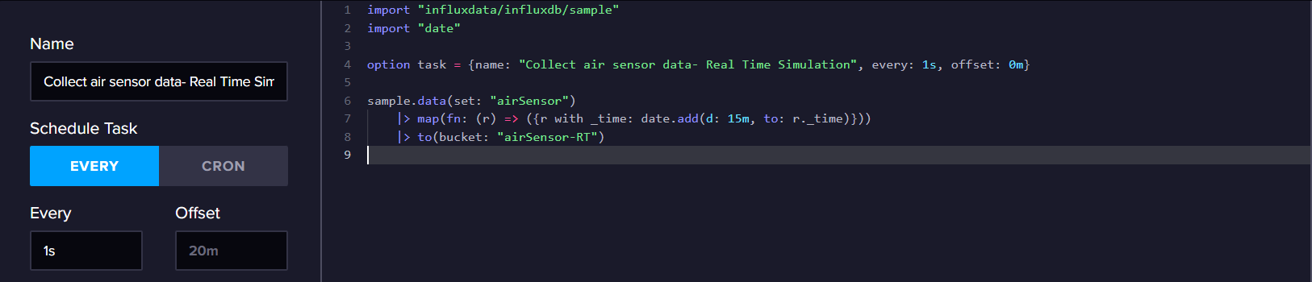

Vrednosti vremena (_time) svake tačke podataka pomeraju se unapred za 15 minuta kako bi se postigao efekat simulacije stvarnog vremenskog toka podataka. Ova praksa se primenjuje zato što se navedeni dataset ažurira svakih 15 minuta. Pomeranjem vremena unapred omogućava se konstantno prisustvo podataka u bazi za trenutni trenutak, što je ključno za funkcionalnost sistema u realnom vremenu.

1. INFLUX DB BAZA

Dobavljeni podaci se smeštaju u bucket pod nazivom "airSensor-RT", i measurement pod imenom "AirSensors". Svaka tačka (point) uključuje field key koji predstavlja "co" (nivo ugljen-monoksida), "humditi" (vlažnost) ili "temperature" (temperatura), odgovarajući field value, kao i vrednost tag-a "sensorId". Ova vrednost čuva string oznaku kancelarije u kojoj je zabeleženo merenje. Naravno, svaka tačka sadrži i vreme zabeleženog merenja, označeno sa "_time".

U cilju poboljšanja performansi, InfluxDB grupiše podatke u tabele, omogućavajući brže pretraživanje baze. U ovom konkretnom slučaju, "sensorId" je korišćen kao tag, što znači da je struktura baze podataka optimizovana za upite po vrednostima u polju "sensorId". U istoj tabeli će se naći podaci koji dele istu vrednost za measurement, tag set i field key. Ovaj pristup omogućava efikasno organizovanje podataka i ubrzanje pretraga, posebno kada je fokus na vrednostima u polju "sensorId".

U skladu sa tim napisani su zadaci koji se periodicno izvrsavaju nad bazom provjeravajuci trenutno izmjerene vrijednosti svih senzora i obavjestavajuci aplikativni dio Sistema o izmjerenim vrijednostima.

# UVOD

Имплементиран информациони систем се бави сакупљањем, чувањем и надгледањем података добијених путем сензора постављених у канцеларијама пословне зграде.